CAS PY 106

In-Class Note 3

Electric Field

1. Charge Q
2. 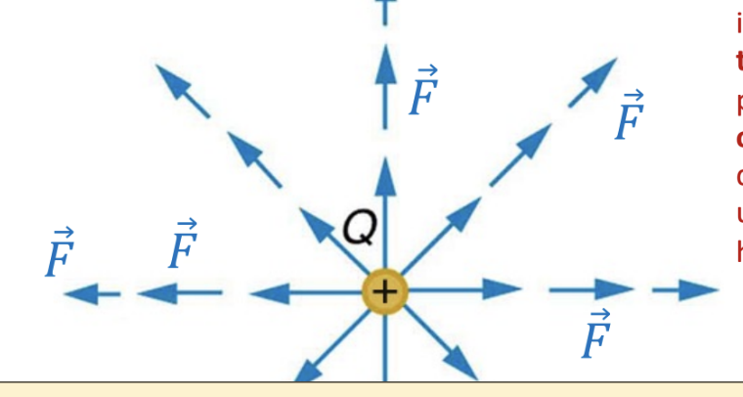
3. Force depends on the charge +q of the test charge

F = k qQ/r^2 \* r hat

r-hat symbol indicates that the force is pointing outward in the radial direction. The phrase “pointing radial outward” to indicate that direction is also ok to use instead of this “r-hat” symbol

\*\*r hat is not actual distance\*\*

1. Electric field E
2. If we have a small test charge and put it around charged object, we can map out an “electric field”- which has magnitude and direction at every point in space
3. Electric field, E, plays a similar role for charged objects that g does for objects that have mass
4. Fg = mg = ma 🡪 a = g
5. Fe = qE = ma 🡪 a = qE/m
6. Net electric field at any given point is the vector sum of the individual electric fields at that point
7. E = kQ/r^2 \* r-hat or E =kQ/r^2 with just the magnitude where r is the distance between the source (one you are choosing) and your target
8. Units 🡪 Electric field 🡪 N/C
9. 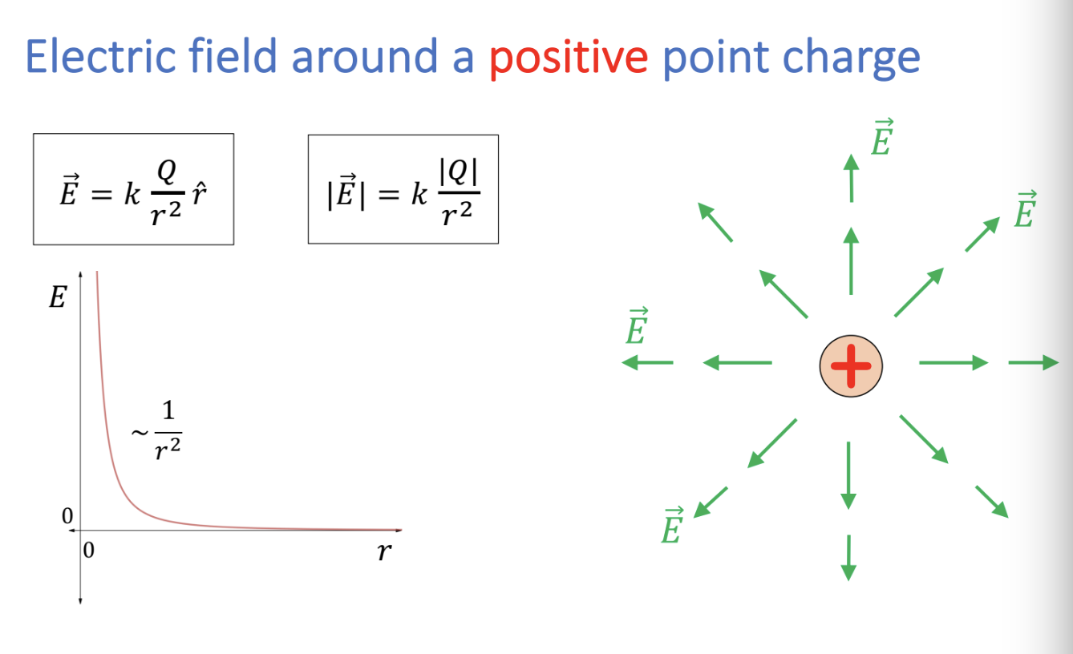
10. 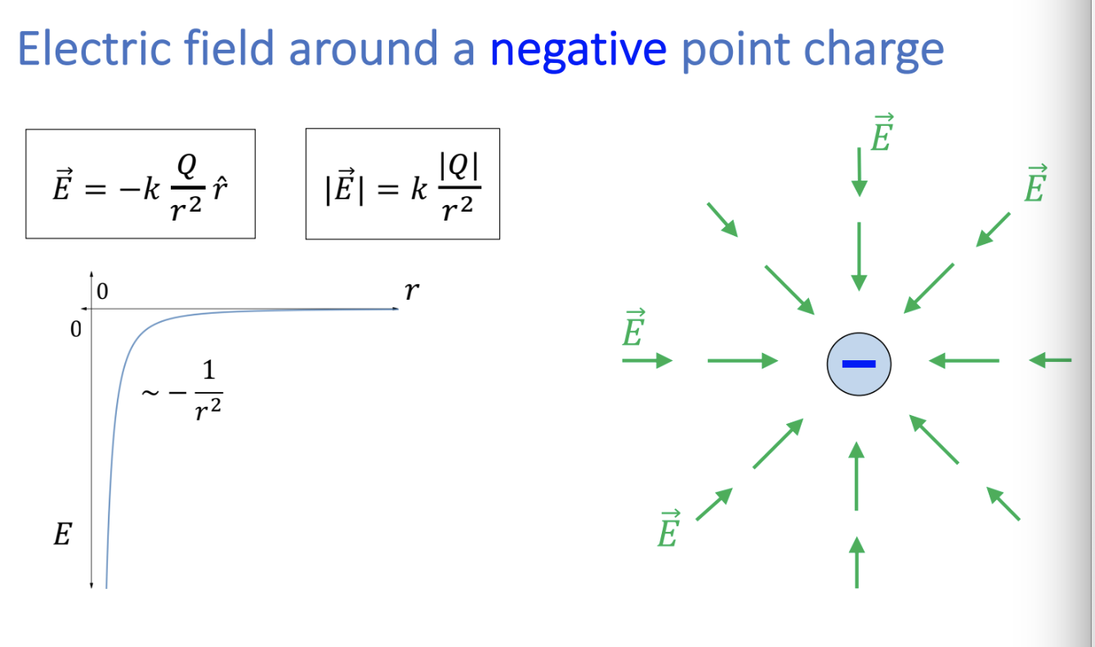
11. Electric dipole viewed with E-field lines, F = qE
12. 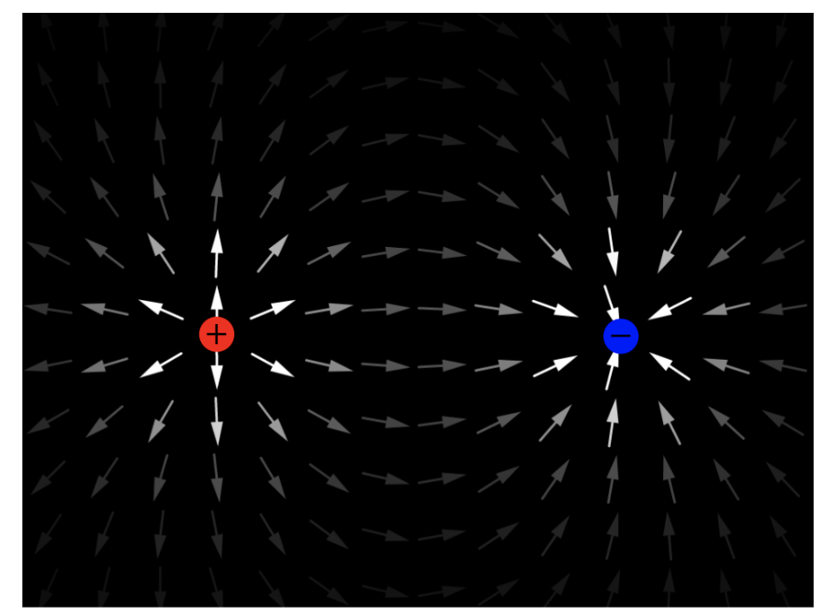
13. 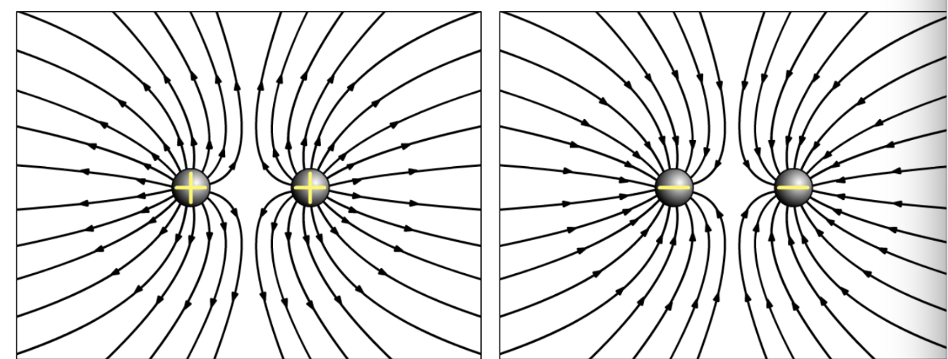
14. Electric field lines from real charged objects
15. 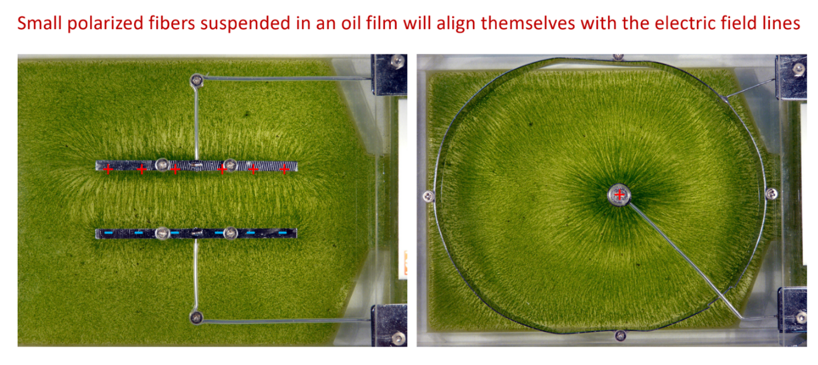
16. 